Govt. Degree College, Rajampeta
Department of Physical Education
Academic year: 2021 - 2022
1. Name of the Activity | Capacity Building Programme
2. Name of the Lecturer | Sri C.Vijaya Bhaskar
3. Date | 15-06 -2022
4. Number of students participated | 15
5. Number of faculty involved | 3
6. Aim & Objectives:

- Make orientation of students towards positive manner
- Increase body building of students
- Changing infrastructure in ground towards for preparation of agnipath programme

7. Brief Report

- An orientation programme conducted to NCC cadets on Agni veer programme was launched by Central Government and disseminate the information to students about the modalities and advantages and disadvantages.
- Make ready to gym by conducting minor repairs
- In ground establishment of Long jump court, Parallel bars, Horizontal bars
- Classes regarding physical training commenced from July 1st 2022 to august 31 2022
- One student Palluru Kishore IInd BSc MSCs got selection, selection communication pasted in next pages

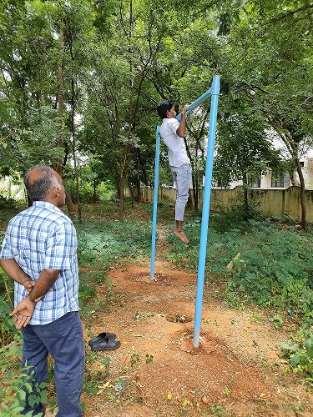
Photo with caption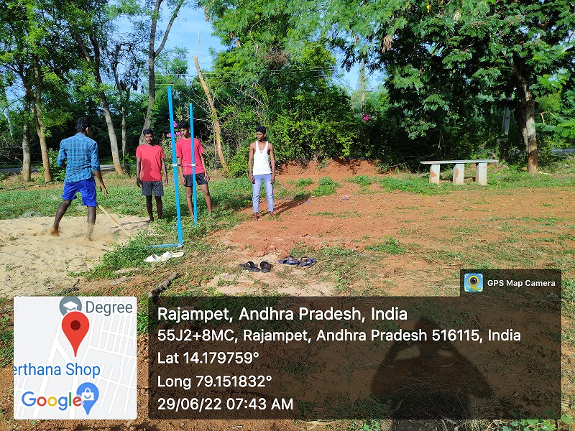
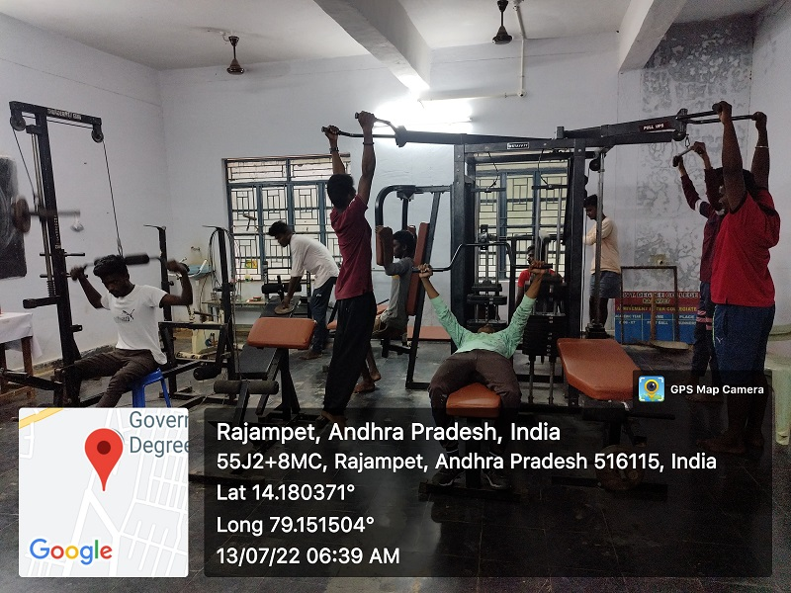

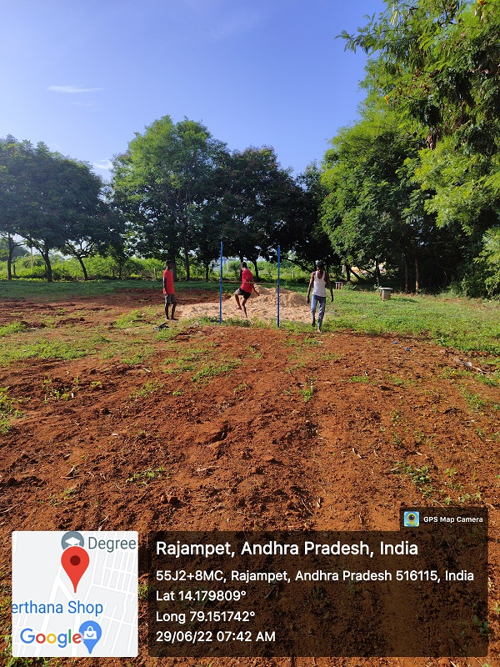

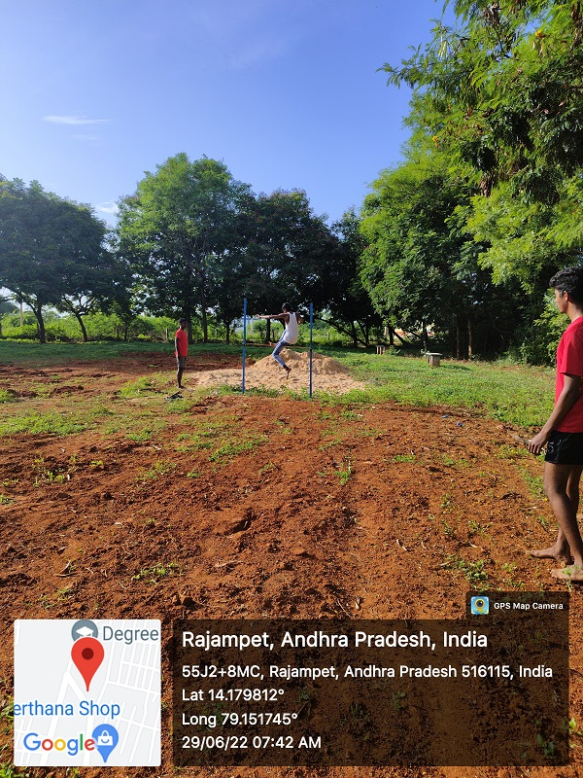

Agnipath Selection
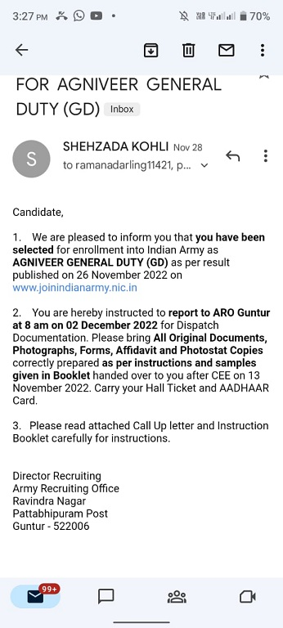
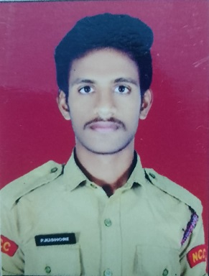
PALUKURI KISHORE
2nd B.SC(MSCS)
6305161634

